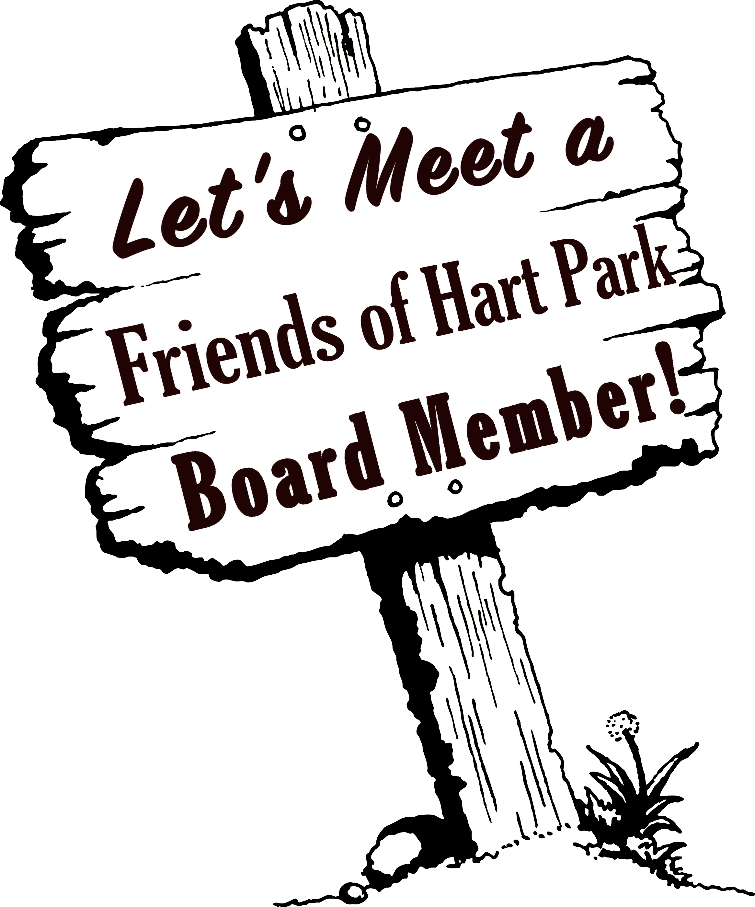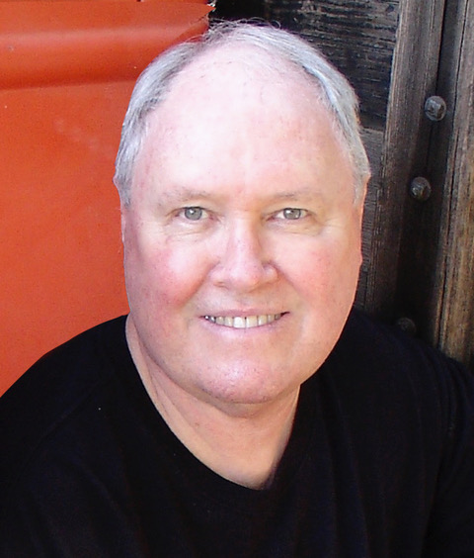

**Tim Murphy**

*Kicking off a new series, we thought it would be fun to meet the Friends of Hart Park board members! –ed.*

**Tell us about yourself**

I grew up in the Mission Hills area of the San Fernando Valley and later I lived in Canoga Park & Chatsworth. After High School I went to Cal Arts the first year it opened in Valencia. I worked as a craftsman on theater and film projects making props and sets, sculpting, painting and mold-making. In 1985, I started my own ceramic tile business, TIMELESS TILE, and distributed my custom line of decorative tiles through high-end tile stores around the country. I moved my business to Santa Cruz, CA in 1993 for the next 22 years, until 2015. After 30 years of tile making, I retired and moved to Valencia in order to care for my 93 year old Mother. Who, by the way, is doing great!

**Tell us about your artwork. What Inspires you.**

I am a multi-media artist, and have created many different works of art utilizing my skills in drawing, sculpting, watercolor, air brush, pastel, oil painting, experimental films, audio soundtracks and music recording, animation, ceramic tiles, masks, feather tapestries, bronze casting, mold making, photography and computer graphic arts.

I’m inspired by many things, but most especially by nature. I also love Early California Impressionist paintings (like the ones in the Irvine Museum collection).

**What got you interested in serving on the FOHP board?**

I visited the Hart Mansion and met Margi Bertram in 2013. Being a tile maker at the time, I was very interested in finding out more about the tile in Bill Hart’s house. So, I contacted my friends at the TILE HERITAGE FOUNDATION, in Northern California, and sent them pictures. The Foundation identified the manufacturer as the American Encaustic Tile Company. In return for their help, I wrote an article about the Hart Mansion tile for their newsletter. My visits to the mansion became more frequent and, Laurene Weste, who I had known for many years, asked if I wanted to help out at Silents Under The Stars and then other events at the mansion, including Cowboys and Carols, which I did for the last few years. That led me to become involved in Friends Of Hart Park.

**What is your favorite thing/place in Hart Park?**

The Hart Mansion is my favorite place at Hart Park because it is a time capsule of when Bill hart lived there. I always feel so fortunate to be able to visit such an amazing place. After all the times I’ve been there, that feeling has never gone away.

My favorite things in the Mansion are the paintings; and the Native American artifacts, like the Navajo rugs and beaded moccasins.

**Outside of serving on the FOHP board, what things do you like to do?**

My most recent project was a labor of love that took almost a year to complete. It’s a 46 page photo book with an accompanying 42 minuet digital DVD movie, about my “family history”.

I enjoy painting watercolors and sitting in on film classes at Cal Arts.

**What would folks be surprised to learn about you?**

I was a child actor in TV commercials as a kid.